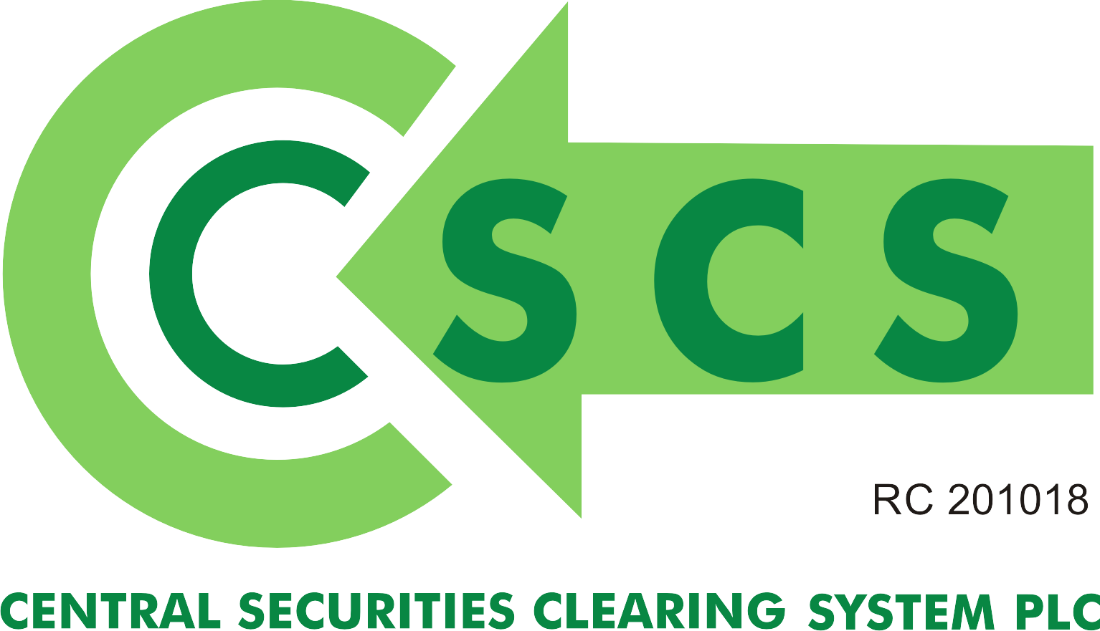

{FORM 1}

JOINT MEMORANDUM FOR LIEN

The Managing Director
Central Securities Clearing System Plc
Stock Exchange House
2/4 Customs Street
Lagos

All information/data to be typewritten please

Dear Sir,

Use of Securities in CSCS Plc Depository as Collateral for Loan Facility
-----------------------------------------------------------------------------------

J O I N T M E M O R A N D U M FOR LIEN (‘JML’)

THIS AGREEMENT is dated the ............................. day of....................................
20

BETWEEN ..................................................................... of..............................................................
{Hereinafter referred to as the “Borrower/Shareholder/Bondholder”}

AND

..............................................................................., a company incorporated in Nigeria and having its registered office at ..................................................................................... {Hereinafter referred to as the “Lender”}.

Both Lender and Borrower/Shareholder/Bondholder are also referred to herein as ‘Party’ individually and ‘Parties’ jointly.

In consideration of the sum of =N= ..................................................... which the Lender granted to the
Borrower/Shareholder/Bondholder pursuant to a loan agreement dated [insert date]
(“Loan Agreement”), we hereby jointly agree as follows:

1. This Joint Memorandum for Lien (otherwise referred to as ‘JML’) is made in fulfillment of the requirements of Central Securities Clearing System Plc {“hereinafter referred to as “CSCS Plc”} for the use of securities as collateral for loan facility.

2. Upon placement of a lien on the securities, the particulars of the account wherein the collateralized securities is held shall bear the Lender’s name provided that the Borrower/Shareholder/Bondholder’s reversionary interest shall be maintained over the collateralized securities subject to full repayment of the loan facility before or at the termination of the Lien.

3. CSCS Plc is hereby authorized to place a lien on the following securities in its Depository until it receives a written authorization “notice of release” from the Lender stating that the Borrower/Shareholder/Bondholder has fully paid or liquidated his/her outstanding debt to the Lender and requesting CSCS Plc. to lift the lien on the securities.

Security  .............................. | Volume  .......................... | CSCS Plc Investor’s A/C No.  .............................................
.............................. | .......................... | .............................................
.............................. | .......................... | .............................................
.............................. | .......................... | .............................................
.............................. | .......................... | .............................................
.............................. | .......................... | .............................................
.............................. | .......................... | .............................................
.............................. | .......................... | .............................................
.............................. | .......................... | .............................................
.............................. | .......................... | .............................................
.............................. | .......................... | .............................................

i. Please note that this list is not exhaustive and may be extended to accommodate all the securities, which Parties have agreed, should be placed under lien.

ii. Parties may agree to accept the use of amortized bonds as collateral for lien and CSCS Plc shall accept this class of securities on ‘as it is’ basis and shall not bear any responsibility for any diminution in the value of the securities during the subsistence of the lien, but only notifies the lender of the tenor of the securities prior to placement of the lien.

iii. CSCS Plc shall not accept any bond(s) whose maturity date is shorter than the tenor of lien being placed at the Depository.

4. After CSCS Plc has placed a lien on the securities, CSCS Plc shall issue a written notice to the parties informing them that a lien has been placed. Note: if the securities placed on lien is/are FGN bond(s), CSCS Plc shall also notify/update the CBN, who is the Registrar, of the lien placement.

5. (a). Duration: The lien shall be in place until the Borrower has fully repaid or liquidated the outstanding debt to the Lender except terminated in accordance with sub clause (d) below.

(b) Draw Down: The draw down date is as contained in the Loan Agreement executed by the Parties and dated [insert date] or as agreed by the Parties

(c) Loan Due Date: The loan due date shall be as determined by the Lender and Borrower in accordance with the terms of the Loan Agreement signed by both Parties and which CSCS Plc shall be notified of.

(d) Lien Termination: This Lien can only be terminated if:

i. the Borrower/Shareholder/Bondholder has repaid the Loan amount to the Lender and both Parties have forwarded a letter duly signed by both of them informing CSCS Plc that the Borrower has repaid the Loan and that the securities placed on Lien should be released to the Borrower.

ii. the Borrower/Shareholder/Bondholder seeks to liquidate part of the securities in furtherance of repayment of the Loan with the consent of the Lender and both Parties have forwarded a letter duly signed by both of them informing CSCS Plc of the part liquidation.

iii. the Borrower/Shareholder/Bondholder defaults in repayment of its outstanding debt to the Lender and the Lender exercises its power of sale in accordance with the provisions of Paragraph 7 below.

(e) CSCS shall automatically renew the lien annually except CSCS Plc is notified by the Lender on or before the occurrence of the said date that the Borrower has fully paid or liquidated its outstanding debt to the Lender and therefore CSCS Plc should release the lien.

(f) Where the lien is automatically renewed, CSCS Plc shall continue to charge fees for its provision of lien renewal services effective on the anniversary date next day after the due/expiration date of placement of lien and the fees shall be based on its current lien renewal fees, which shall be included in CSCS Plc Products/Services Charges as published on CSCS Plc website.

(g) Lender shall ensure that fees relating to placement of lien are fully paid to CSCS Plc in satisfaction of condition for release of lien.

6. The Borrower/Shareholder/Bondholder hereby undertakes to fully redeem his/her outstanding debt or other financial obligations to the Lender in accordance with the terms of the Loan Agreement.

7. The Lender reserves the right to sell the securities or any part thereof upon the occurrence of an event of default as contained in the Loan Agreement without recourse to the Borrower/Shareholder/Bondholder provided that the following conditions have been satisfied by the Lender:

- In the course of placing the Lien, the Lender must furnish CSCS Plc with copies of duly executed JML by both Parties.

- The Lender must furnish the CSCS Plc with a letter from the Borrower/Shareholder/Bondholder authorizing the Lender to sell the securities in the event of a default in payment by the Borrower.

Please note that the Borrower/Shareholder/Bondholder is required to provide a copy of the undated letter to the Lender upon execution of the JML and the letter must include a power of authority from the Borrower/Shareholder/Bondholder to the Lender allowing the Lender to date the undated letter of authority for the purpose of enforcement. The Lender is required to hold on to the undated letter and shall subsequently date same whilst presenting it to CSCS Plc as proof of Lender’s authority to sell the securities where the Borrower defaults in payment.

- Lender shall notify CSCS Plc of its intention to foreclose on the loan facility to the Borrower and to exercise its right to possess/sell the collateralized securities following Borrower’s default of terms agreed under this JML.

(c) To effect the sale, the Lender shall issue a letter to the CSCS Plc instructing it to move the securities to a designated Stock Brokerage Firm or Primary Dealer Market Maker (PDMM).
- The Borrower/Shareholder/Bondholder waives any rights he/they may have of first requiring the Lender to proceed against or enforce any other rights or security before enforcing its rights to sell the securities

- No failure to exercise and no delay on the part of the Lender in exercising any right, remedy, power or privilege under JML and no course of dealing between the Borrower/Shareholder/Bondholder and the Lender shall be construed or operate as a waiver of that right, remedy, power or privilege on the Lender’s part, nor shall any single or partial exercise of any such right, remedy, power or privilege preclude any other or further exercise of it or the exercise of any other right, remedy, power or privilege.

8. This JML shall not be affected by the following:

- any variation of, or amendment or addendum (however fundamental) to, or replacement of, the Loan Agreement(s) and/or any other document relating to the loan facility granted to the Borrower/Shareholder/Bondholder;

- any unenforceability, illegality or invalidity of any document or security or any of the obligations in respect of the loan facility granted to the Borrower/Shareholder/Bondholder; to the extent that the obligations herein incurred shall remain in full force and this JML shall be construed accordingly as if there were no such unenforceability or invalidity;

- any incapacity, lack of power or authority on the part of the Borrower/ Shareholder/Bondholder.

9. Upon the occurrence of an event of default, the Lender shall ensure that its right of sale shall be exercised only on the portion of the securities equal to the total value of the outstanding debt obligations and required to repay same.

10. Upon a written demand for withdrawal from the Borrower to CSCS Plc stating that the securities exceed the debt obligations to the Lender, the Borrower may with the consent of the Lender withdraw part of the securities to maintain a value commensurate with its debt obligations provided that the following conditions have been satisfied:

- The Borrower/Shareholder/Bondholder must provide evidence of the values of the securities,
- A letter of notice to withdraw must be delivered to the Lender;
- A letter of approval must be received from the Lender.

11. Upon a written demand for substitution from the Borrower /Shareholder/Bondholder to CSCS Plc stating that the Borrower intends to substitute the securities with another set of securities, the Borrower may with the consent of the Lender substitute all or part of the collateral securities provided that the following conditions have been satisfied:

- The Borrower/Shareholder/Bondholder must provide proof of ownership of substitute securities which should be confirmed by its/his/her Stockbrokers;
- A letter of notice to substitute must be delivered to the Lender;
- A letter of approval must be received from the Lender.

Provided always that a substitution of securities shall not be made until the Borrower/Shareholder/Bondholder furnishes the substitute securities to CSCS Plc.

12. CSCS Plc shall upon receipt of a notice of release from the Lender to lift the lien on the securities proceed to lift the lien without recourse to the Borrower/Shareholder /Bondholder and is free from any liability for so doing.

Note: if the securities for which the lien has been placed and now subsequently being lifted is/are FGN bond(s), CSCS Plc shall also notify/update the CBN, who is the Registrar, of the lifting of the lien.

13. Any instruction issued to the CSCS Plc shall be in accordance with this JML. The Lender/Borrower/Bondholder hereby agree that CSCS Plc has no obligation to obey or recognize any instruction which is not in accordance with this JML.

CSCS Plc shall not bear any responsibility whatsoever where any or both Parties fail to fulfill conditions precedent prior to the Lien placement.

14. The Lender/Borrower/Shareholder/Bondholder hereby agree to INDEMNIFY AND HOLD HARMLESS CSCS Plc from any and all liabilities, costs and claims, asserted by, through or under the Lender/ Borrower/Shareholder/Bondholder and arising either directly or indirectly from any breach of the terms of this JML or the Loan Agreement executed by the Parties thereto.

15. The Borrower/Shareholder/Bondholder hereby confirms that the Borrower/Shareholder/Bondholder is the owner of the securities and/or has received valid authorization from a related party or entity for the securities used as collateral to secure the loan and that the securities are genuine and free from any encumbrance. CSCS Plc shall not be liable to the Lender or the Borrower/Shareholder/Bondholder for relying on this representation and shall be indemnified by the Borrower/Shareholder/Bondholder for any liability arising from relying on this representation.

16. Prior to the exercise of the Lender’s right of sale the beneficial interest in the securities shall remain in the Borrower and shall not be considered as property of CSCS Plc or the Lender.

17. In the event that a Party either as plaintiff/claimant or defendant/counterclaimant (the ‘Responsible Party’) applies to the Court to join CSCS Plc as a party to any dispute, claim or action arising out of, or in relation to, the interpretation or execution of this JML, the Responsible Party shall defray any and/or every costs, losses and liabilities of CSCS Plc (including defraying CSCS Plc’s counsel’s fees reasonably incurred and incidental expenses such as filing fees, cost of obtaining certified true copies of documents, cost of transportation, bailiff’s fees etc.) which are directly incurred by CSCS Plc (the ‘Costs’) as a result of being joined as a party.

Consequently:

- Whenever a bill for professional fees and expenses is served on CSCS Plc by its counsel, CSCS Plc shall pass same onto the Responsible Party who shall make payment directly to CSCS Plc’s counsel within 30 days from the day the bill is received;

- Where the Responsible Party fails, refuses or neglects to pay the bill within the period stipulated in (a) above, CSCS Plc shall:

- forthwith cease to render services to the Responsible Party until it receives confirmation from its counsel that the bill has been paid;

- In the first instance apply to the Court where the matter has been instituted against CSCS Plc, praying same Court to make a suitable order obligating the Responsible Party to defray its counsel’s fees as provided for above before CSCS Plc can continue to appear in the matter.

18. The Parties hereby confer on CSCS Plc an enforceable right of action against either or both of the Lender or Borrower/Shareholder/Bondholder in the event of a breach any clause contained in this particularly clauses 9, 10, 11 and 12 of this JML. Hence the common law doctrine of privity of contract is inapplicable to this JML and cannot operate to deprive CSCS Plc of any or all of the rights conferred on it by this JML.

19. The Parties hereby undertake that where e-bonus shares occur during the pendency of the Lien placement of specific shares, same e-bonus shares shall form part of the Lien and therefore should be lodged in the said Lien Account.

20. The obligations of the Lender and Borrower/Shareholder/Bondholder under this JML are several. Failure of any Party to perform its respective obligations under this JML does not affect the other Party’s obligations.

21. If any provision of this JML shall be held wholly or partly invalid, illegal or unenforceable for any reason whatsoever, then those provisions shall be deemed severable from the remaining provisions of this JML and shall in no way affect the validity, legality or enforceability of this JML.

22. This JML may be executed in counterparts, each of which together constitutes a single agreement between the parties but shall not be effective until each party has executed at least one counterpart. Each such counterpart shall be deemed to be an original, but all the counterparts shall together constitute the JML.

23. This JML is governed by Nigerian law.

Dated this ...........................................day of.............................................................20...... SIGNED by the within named Borrower/Shareholder/Bondholder:
..........................................................................

In the presence of: (Details of Witness for the Borrower/Shareholder/Bondholder) Name.................................................................... Signature.............................................................
Address................................................................ Date......................................................................

The common seal of the within named Lender is hereby affixed in the presence of:

............................................................... ........................................................... DIRECTOR SECRETARY

We acknowledge receipt of this JML and undertake to perform and comply with its terms as it applies to the Central Securities Clearing System Plc

Name: Name:

Designation: Designation:

Signature: Signature:

Date: Date:

Securities shall include equities, debt instruments and derivatives.

